**School 21 3rd Grade Supply List**

(Look for early sales!)

Please get a small box that will fit inside your child’s desk to put ALL their supplies in!

* 4 boxes of #2 pencils already sharpened (replace throughout the year)

* Pencil sharpener with cap (replace throughout the year)

* 2 Marble notebooks (no spiral, can be different colors)

* 6 Folders (strong plastic ones recommended)

* I Pack of index cards

* 2 Highlighters

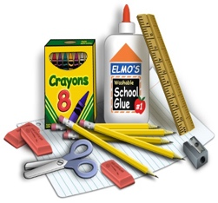

[This Photo](http://pixel-slinger.deviantart.com/art/Elementary-School-Supplies-358344655) by Unknown Author is licensed under [CC BY-NC-ND](https://creativecommons.org/licenses/by-nc-nd/3.0/)

* 3 Packs of dry erase markers and eraser

*Multiplication flash cards (Dollar stores)

*Small box of crayons or colored pencils

*Box of washable colored markers

*1 Elmer’s glue

*Pack of glue sticks

*2 scotch tapes

*1 Pack *wide ruled loose-leaf paper*

*Cursive writing “workbook” (Target, Walmart, bookstores, or online)

HOUSEKEEPING SUPPLIES:

* **4** boxes of tissues
* **3** Lysol wipes
* **3** baby wipes
* **2** bottles hand sanitizer
* **2** rolls of paper towels.
* **2** box of small Ziplock bags

THANK YOU!

PLEASE PUT YOUR CHILD’S NAME ON EVERYTHING

Mrs. Carone (3-31)